**Final Year Project**

**FYP Team**

**Muhammad Ashar Zafar 20F – 0240**

**Muhammad Ehsan Akhtar 20F – 0312**

**Muhammad Shahzaib Shahfiq 20F – 0317**

**Supervised by:**

**Mr. Tahir Farooq**

**Co – supervisor by:**

**TBD**

**Department of Computer Science**

**National University of Computer and Emerging Sciences**

**Chiniot – Faisalabad Campus, Pakistan.**

**2023**

**Abstract**The "Student Support and Navigation Application" (SSNA) is a comprehensive mobile application designed to address the challenges faced by new batch students as they transition into campus life. This application serves as an invaluable tool to enhance their experience by providing easy access to essential services and information. The SSNA encompasses various modules including chat functionality, bus schedules, a marketplace for buying and selling items, a campus map, a timetable management system, contact directories, a complaint/report system, and hostel information. Through the SSNA, new students can seamlessly navigate their daily routines, find classrooms, interact with seniors for guidance, and access the assistance they require. This abstract provides a brief overview of the SSNA and highlights its key features, demonstrating its potential to significantly improve the on-campus experience for incoming students. The detailed documentation will delve into each module's functionality, design, and implementation, offering insights into how the SSNA can be effectively utilized to support and empower new batch students in their academic journey.

**Contents**

**1.** **Vision Document:** i

**1.1.** **Introduction** i

**1.1.1.** ***Problem Statement*** i

**1.1.2.** ***Objectives*** i

**1.2.** **Motivation** ii

**1.3.** **Overview** ii

**1.4.** **Features** ii

**1.4.1.** ***User registration and authentication*** ii

**1.4.2.** ***Chat module*** ii

**1.4.3.** ***Timetable management*** iii

**1.4.4.** ***Campus map*** iii

**1.4.5.** ***Transportation*** iii

**1.4.6.** ***Marketplace*** iii

**1.4.7.** ***Contact directory*** iii

**1.4.8.** ***Complaint system*** iv

**1.4.9.** ***Hostel information*** iv

**1.4.10.** ***Notification and alerts*** iv

**1.4.11.** ***User profile*** iv

**1.4.12.** ***Setting and preferences*** iv

**1.4.13.** ***Feedback and support*** iv

**2.** **Tools and technologies** v

**3.** **Required hardware and software resources** v

**3.1.** **Hardware** v

**3.2.** **Software** v

**4.** **High level diagram** vi

**5.** **Timeline** vi

# **Vision Document:**

## **Introduction**

In an era defined by digital innovation and connectivity, educational institutions are constantly seeking ways to enhance the student experience both inside and outside the classroom. Recognizing the evolving needs of modern-day students, we embark on an ambitious project to create an all-encompassing mobile application tailored specifically for university communities. This project aims to revolutionize campus life by providing students with a powerful tool that not only streamlines their academic journey but also fosters engagement, communication, and convenience. Our comprehensive university mobile app project encompasses a wide range of features and functionalities, all designed to empower students with the tools they need to succeed in their academic pursuits and thrive in the campus environment.

### ***Problem Statement***

The problem in the current system is that there is no central system to assist a student using a single platform. Our app will assist the new batch students as they face a lot of challenges in navigating through their timetable, finding their classrooms, and interacting with seniors for assistance. There is a need for a central system that can handle all these things in one application.

### ***Objectives***

* New batch students face challenges in understanding their timetables and finding classrooms.
* Existing resources like PDFs and separate apps don't provide a comprehensive solution.
* Students need a central platform to access all necessary information and assistance.
* Interaction with seniors for guidance is essential but lacks a straight-forward approach.
* Navigating the campus, especially for newcomers, requires an easy-to-use map.
* Timetable management is crucial for effective time utilization.
* A marketplace for buying and selling items can enhance student convenience.
* Contact information for various departments should be readily available.
* Complaint reporting needs a simple and direct channel.
* Hostel-related information should be easily accessible for hostel students.

## **Motivation**

After research, we have seen that many existing pdfs file for university are not enough to address all the student problems dynamically at once and they are not providing much needed functions which can help students in things like checking campus map, managing timetable, and interacting with seniors easily.

## **Overview**

New batch students face a lot of challenges in navigating through their timetable, finding the classrooms, and interacting with their seniors for assistance/guidance. The students will get access to all the necessary help using this application. This app will include modules like chatting, buses, a marketplace for selling things, campus map, timetable, contact information, complaint/report, hostel.

## **Features**

### ***User registration and authentication***

* New students can register with their university credentials.
* User authentication ensures the security and privacy of user data.

### ***Chat module***

* Real-time chat functionality allows students to communicate with each other.
* Enables interaction with seniors, faculty, and other students for guidance and assistance.
* Group chats and private messaging support effective communication.

### ***Timetable management***

* Allows students to access their class schedules and view upcoming events.
* Notifications for class changes, cancellations, and important dates.
* Integration with academic calendars.

### ***Campus map***

* Interactive map with GPS functionality to help students find classrooms, buildings, and facilities.
* Information about important locations such as libraries, cafeterias, and administrative offices.

### ***Transportation***

* Displays bus schedules and routes for convenient commuting.
* Real-time tracking of campus shuttles.
* Notifications for delays or changes in transportation services.

### ***Marketplace***

* A platform for students to buy and sell textbooks, supplies, and other items.
* Secure payment options and communication between buyers and sellers.
* Listings categorized by item type for easy navigation.

### ***Contact directory***

* Comprehensive directory of faculty, staff, and student contacts.
* Search and filter options to quickly find the desired contact.
* Integration with email and phone applications for easy communication.

### ***Complaint system***

* Enables students to report issues or concerns, such as maintenance problems or safety hazards.
* Tracks the status and resolution of submitted complaints.
* Provides a mechanism for anonymous reporting if desired.

### ***Hostel information***

* Information about on-campus hostels, including availability and pricing.
* Room allocation details and roommate contact information.
* Reporting and tracking of hostel-related issues.

### ***Notification and alerts***

* Push notifications for important announcements, events, or updates.
* Emergency alerts and safety information.
* Personalized notifications based on user preferences.

### ***User profile***

* Allows users to customize their profiles with photos, personal information, and preferences.
* Profile privacy settings to control the visibility of information.

### ***Setting and preferences***

* User-configurable settings for notifications, theme, language, and other app preferences.
* Accessibility options to cater to diverse user needs.

### ***Feedback and support***

* A feedback mechanism for users to provide suggestions or report issues within the app.
* Dedicated support channels for technical assistance.

# **Tools and technologies**

* React Native
* Node JS
* Express JS
* Mongo DB
* Firebase
* Blender
* GitHub

# **Required hardware and software resources**

## **Hardware**

Following development PC is required to develop this project:

|  |  |
| --- | --- |
| Hardware | Specifications |
| Development PC | * Microsoft Windows 7/8/10 (32-bit or 64-bit) * 8 GB RAM recommended. |

## **Software**

The following software are required for the development of this project.

|  |  |
| --- | --- |
| Software | Purpose |
| Flutter/React Native | Default IDE |
| Adobe Photoshop/ Illustrator | Graphic Designing |
| Microsoft Visio | UML Designing |
| Visual Studio | .NET Development |

# **High level diagram**

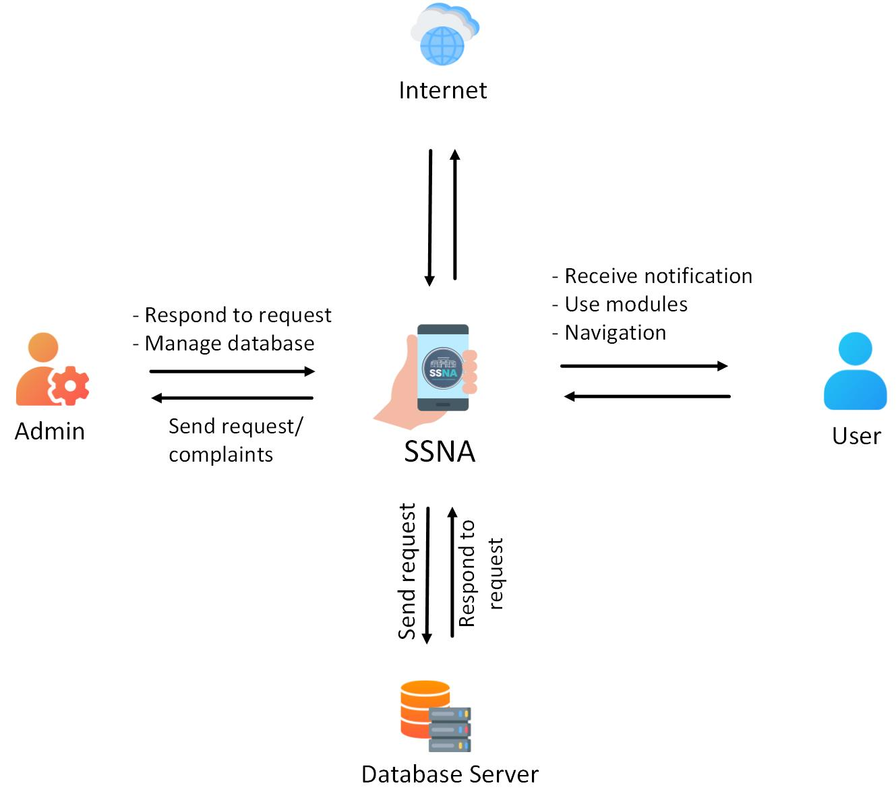

# **Timeline**

